Season of Prayer
Bringing into focus
our changing lives
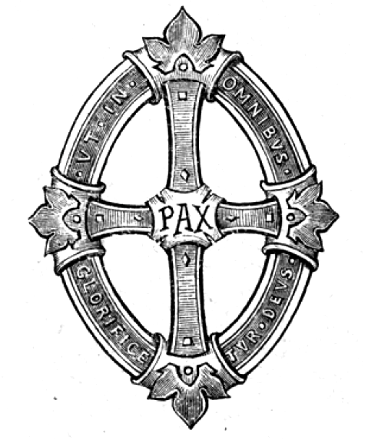
1 October 2020 thru 23 May 2021
St Jude Catholic Church

Dear St. Jude Parish Community,
As we continue together to realize our identity as Disciples who are Called, Nourished, and Sent, the parish staff and I would like to invite you into a new season of Discipleship.
From the Feast of St. Therese of Lisieux (October 1, 2020) through the Feast of Pentecost (May 23, 2021), St. Jude will be embarking on a Season of Prayer. Prayer is essential to our lives as Disciples of Jesus Christ.
As Catholics, we understand that the Mass is our highest form of prayer, but sometimes we struggle to know or enter other forms of prayer. This year, as a parish community, we will be exploring new ways to engage in prayer, both individually and communally. To facilitate this, we will be starting several new initiatives. We will begin groups praying the Liturgy of the Hours.
We will have regular Eucharistic Adoration and Benediction. We will have a weekly Rosary group. We will also have a couple of talks throughout the year, examining different aspects of prayer.
Other opportunities will come up through the year, as together, we journey into prayer.
To begin our year, we will be celebrating a Solemn Evening Prayer (Vespers) on October 1, at 6:00 pm. You are very welcome to join us in person, and we will be live-streaming this event as well.
St. Therese, also known as the Little Flower, is a worthy patron for our year of prayer. In describing prayer, she wrote, “For me, prayer is a surge of the heart; it is a simple look turned toward heaven, it is a cry of recognition and of love, embracing both trial and joy.”
As we enter this year, I hope that our hearts surge towards God, recognizing Him in new ways. Through the intercession of St. Therese, may God also surge towards us.
St. Therese, pray for us!
In Christ,
Fr. Peter Marshall
Liturgy of the Hours
The Liturgy of the Hours, also known as the Divine Office or the Work of God (Opus Dei), is the Church's daily prayer, marking the hours of each day and sanctifying the day with prayer. The Hours are a meditative dialogue on the mystery of Christ, using scripture and prayer. At times, the dialogue is between the Church or individual soul and God; at times, it is a dialogue among the Church members, and at times it is even between the Church and the world. The Divine Office “is truly the voice of the Bride herself addressed to her Bridegroom. It is the very prayer which Christ himself together with his Body addresses to the Father.” (SC 84) The dialogue is always held, however, in the presence of God and using the words and wisdom of God.
Each of the five canonical Hours includes selections from the Psalms that culminate in a scriptural proclamation. The two most important or hinge Hours are Morning and Evening Prayer. These each consists of a Gospel canticle: the Canticle of Zechariah from Luke 1:68-79 for Morning Prayer (known as the Benedictus), and the Canticle of Mary from Luke 1:46-55 for Evening Prayer (known as the Magnificat). The Gospel canticle acts as a meditative extension of the scriptural proclamation considering the Christ event. Morning and Evening Prayer also includes intercessions that flow from the scriptural proclamation just as the Psalms prepare for it.
In the Hours, the royal priesthood of the baptized is exercised, and this sacrifice of praise is thus connected to the sacrifice of the Eucharist, both preparing for and flowing from the Mass.
“The hymns and litanies of the Liturgy of the Hours integrate the prayer of the psalms into the age of the Church, expressing the symbolism of the time of day, the liturgical season, or the feast being celebrated. Moreover, the reading from the Word of God at each Hour (with the subsequent responses or troparia) and readings from the Fathers and spiritual masters at certain Hours, reveal more deeply the meaning of the mystery being celebrated, assist in
understanding the psalms, and prepare for silent prayer. (CCC 1177)
Registration to participate in these opportunities for prayer is not required; however, we are looking for parishioners to serve as prayer leaders throughout the Season. A Sign-Up Genius has been created for those interested in leading the Liturgy of the Hours.

Eucharistic Adoration

Eucharistic Adoration is the adoration of Jesus Christ present in the Holy Eucharist. During Adoration the Eucharist is displayed in a special holder called a monstrance. People come to pray and worship Jesus continually throughout the day and often the night. Christ’s great love for us was shown when he was crucified on the cross to pay the penalty for our sins and give us eternal life. He loves us without limit and offers Himself to us in the Holy Sacrament of the Eucharist. Can we not give Jesus a few minutes of love and adoration in return?
The Blessed Sacrament must not be left unattended during Adoration; as such, Sign-Up Genius will be utilized to ensure coverage throughout the day. You may attend Adoration without registering; however, please sign up if you know for certain you plan to attend. If you are registered for a time slot and are unable to attend, please contact the Parish Office at 317-786-4371 so that coverage can be coordinated. Unique sign-ups have been created for each planned day of Adoration.

The Rosary

The Holy Rosary, also known as the Dominican Rosary, or simply the Rosary, refers to a set of prayers used in the Catholic Church and to the string of knots or beads used to count the component prayers.
The prayers that comprise the Rosary are arranged in sets of ten Hail Mary’s, called decades. Each decade is preceded by one Lord’s Prayer (“Our Father”) and followed by one Glory Be and the Fatima Prayer (“O my Jesus”). During recitation of each set, thought is given to one of the Mysteries of the Rosary, which recall events in the lives of Jesus and of Mary. Five decades are recited per rosary. Rosary beads are an aid towards saying these prayers in the proper sequence.
Pope Pius V (1566–1572) established a standard 15 Mysteries of the Rosary, based on long-standing custom. This groups the mysteries in three sets: the Joyful Mysteries, the Sorrowful Mysteries, and the Glorious Mysteries. In 2002, Pope John Paul II established the Luminous Mysteries, bringing the total number of mysteries to 20. The Glorious Mysteries are said on Sunday and Wednesday, the Joyful on Monday and Saturday, the Sorrowful on Tuesday and Friday, and the Luminous on Thursday.
Over more than four centuries, several popes have promoted the Rosary as part of the veneration of Mary in the Catholic Church, and consisting essentially in meditation on the life of Christ. The rosary also represents the Catholic emphasis on “participation in the life of Mary, whose focus was Christ”, and the Mariological theme “Christ through Mary”.
Registration to participate in these opportunities for prayer is not required; however, we are looking for parishioners to serve as prayer leaders throughout the Season. A Sign-Up Genius has been created for those interested in leading the Rosary.

St. Jude Novena

In the name of the Father, and of the Son,
and of the Holy Spirit. Amen.

Most holy St. Jude – apostle, martyr and friend of Jesus, today I ask that you pray for me and my intentions!

(State your intentions here)

You are the patron of the impossible.

Pray for me and my intentions!

O St. Jude, pray that God’s grace and mercy
will cover my intentions.

Pray for the impossible if it is God’s will.

Pray that I may have the grace to accept God’s holy will
even if it is painful and difficult for me.

St. Jude, you loved our Lord, help me to love Him more.

O St. Jude, pray for me that I may grow in faith, hope and love
and in the grace of Jesus Christ.

Pray for these intentions, but most of all pray
that I may join you in heaven with God for all eternity.

Amen.
In the name of the Father, and of the Son,
and of the Holy Spirit. Amen.

Devotion
What Spiritual aids helped you to nurture your union with Christ this month?

Study
What have you done this month to better recognize God’s gift?

Action
What apostolic success did the Lord want to accomplish in His Church through you this month?

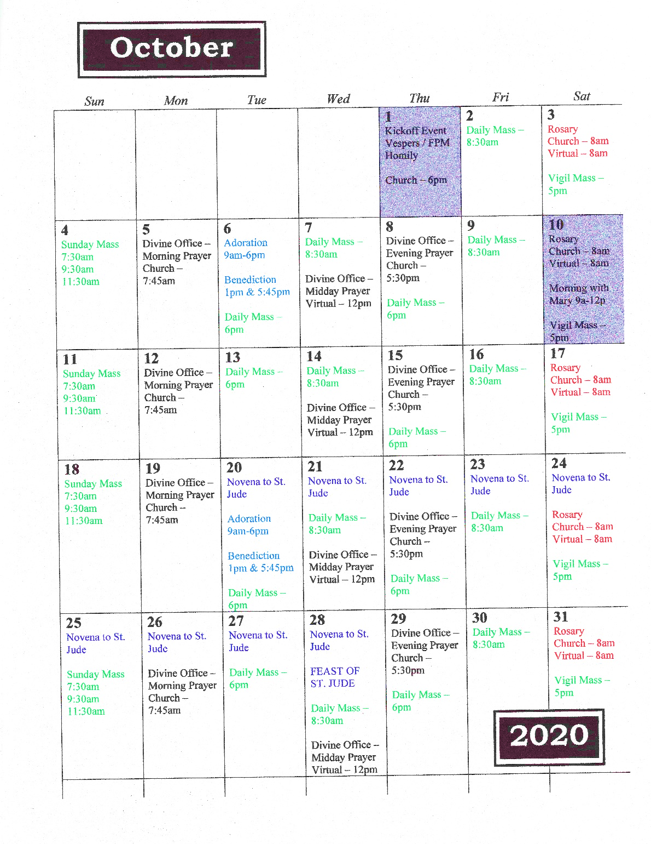

Devotion
What Spiritual aids helped you to nurture your union with Christ this month?

Study
What have you done this month to better recognize God’s gift?

Action
What apostolic success did the Lord want to accomplish in His Church through you this month?

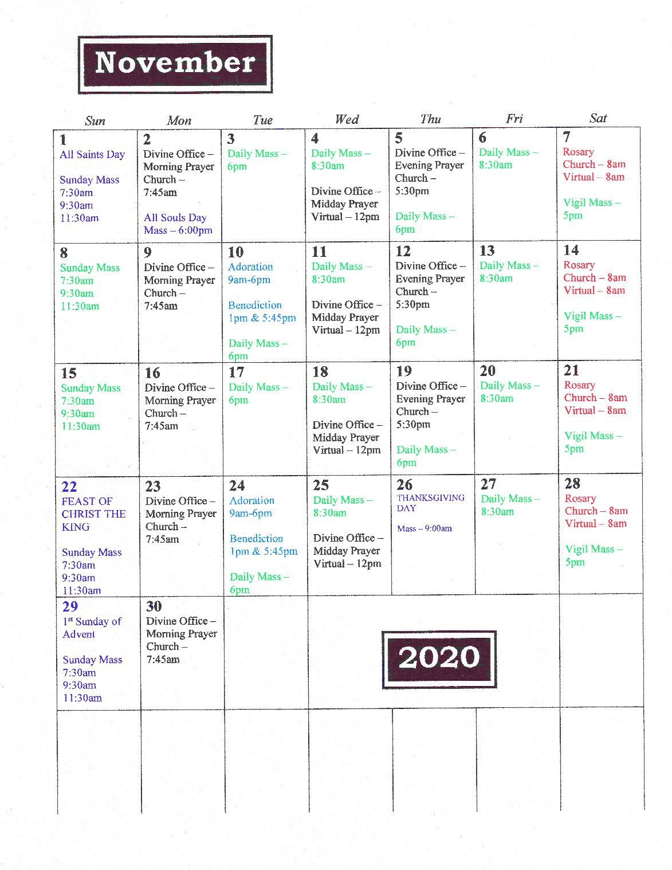

Devotion
What Spiritual aids helped you to nurture your union with Christ this month?

Study
What have you done this month to better recognize God’s gift?

Action
What apostolic success did the Lord want to accomplish in His Church through you this month?

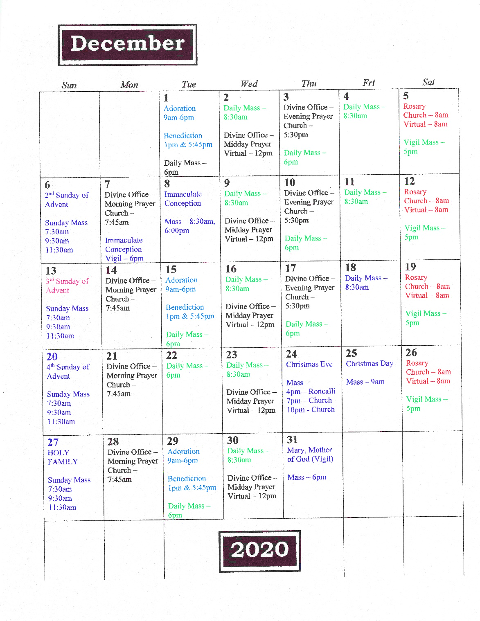

Devotion
What Spiritual aids helped you to nurture your union with Christ this month?

Study
What have you done this month to better recognize God’s gift?

Action
What apostolic success did the Lord want to accomplish in His Church through you this month?

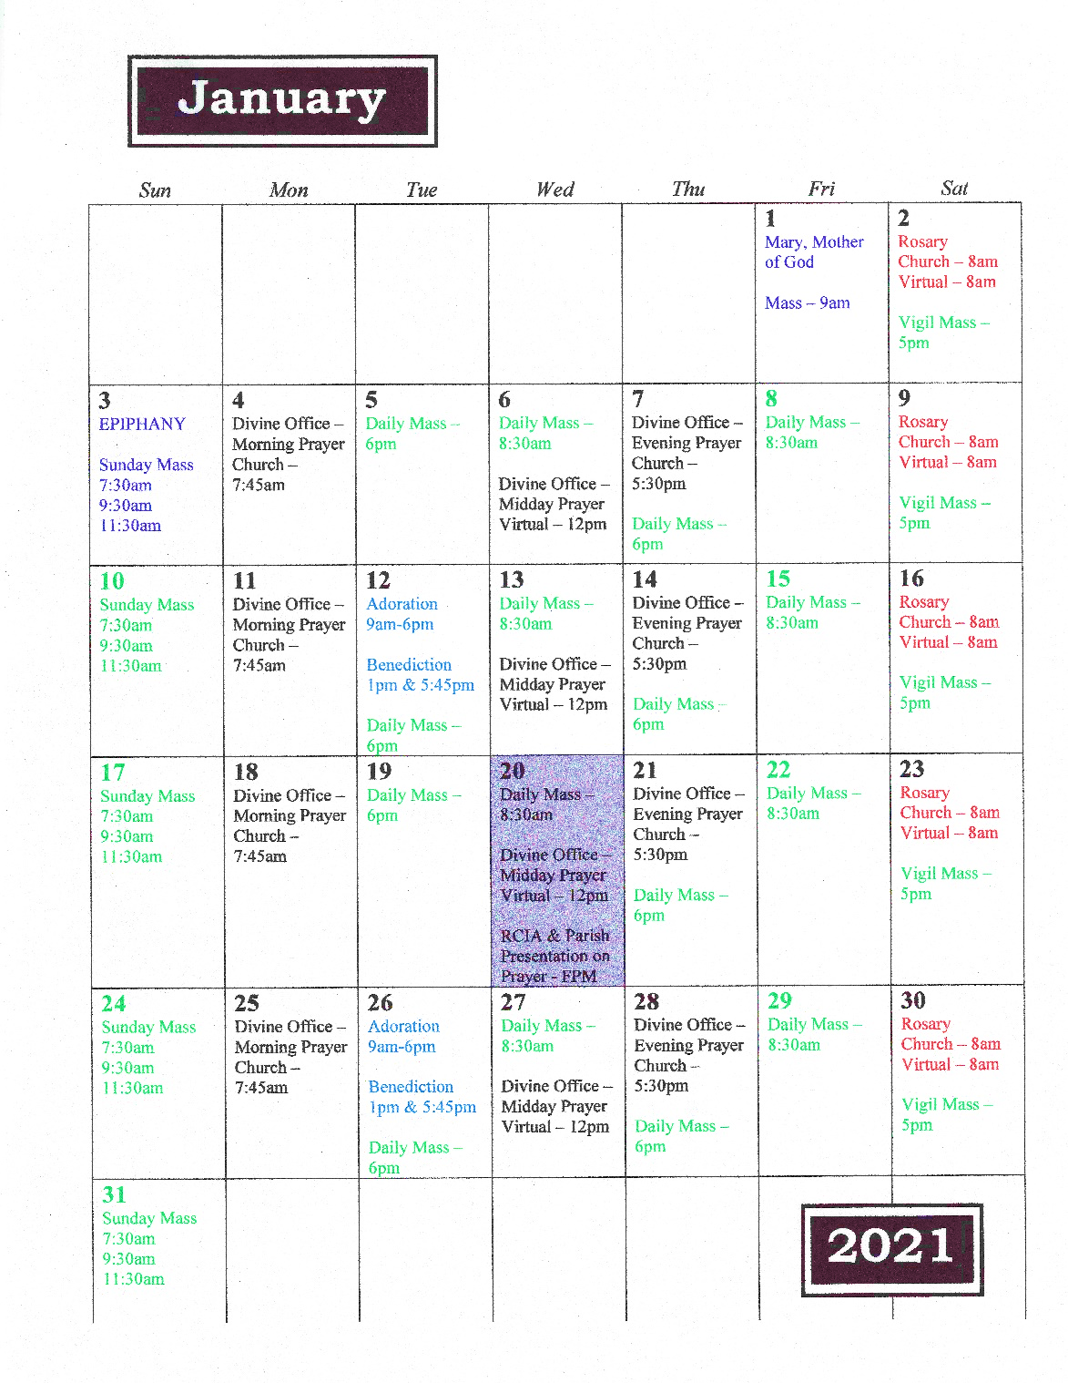

Devotion
What Spiritual aids helped you to nurture your union with Christ this month?

Study
What have you done this month to better recognize God’s gift?

Action
What apostolic success did the Lord want to accomplish in His Church through you this month?

Devotion
What Spiritual aids helped you to nurture your union with Christ this month?

Study
What have you done this month to better recognize God’s gift?

Action
What apostolic success did the Lord want to accomplish in His Church through you this month?

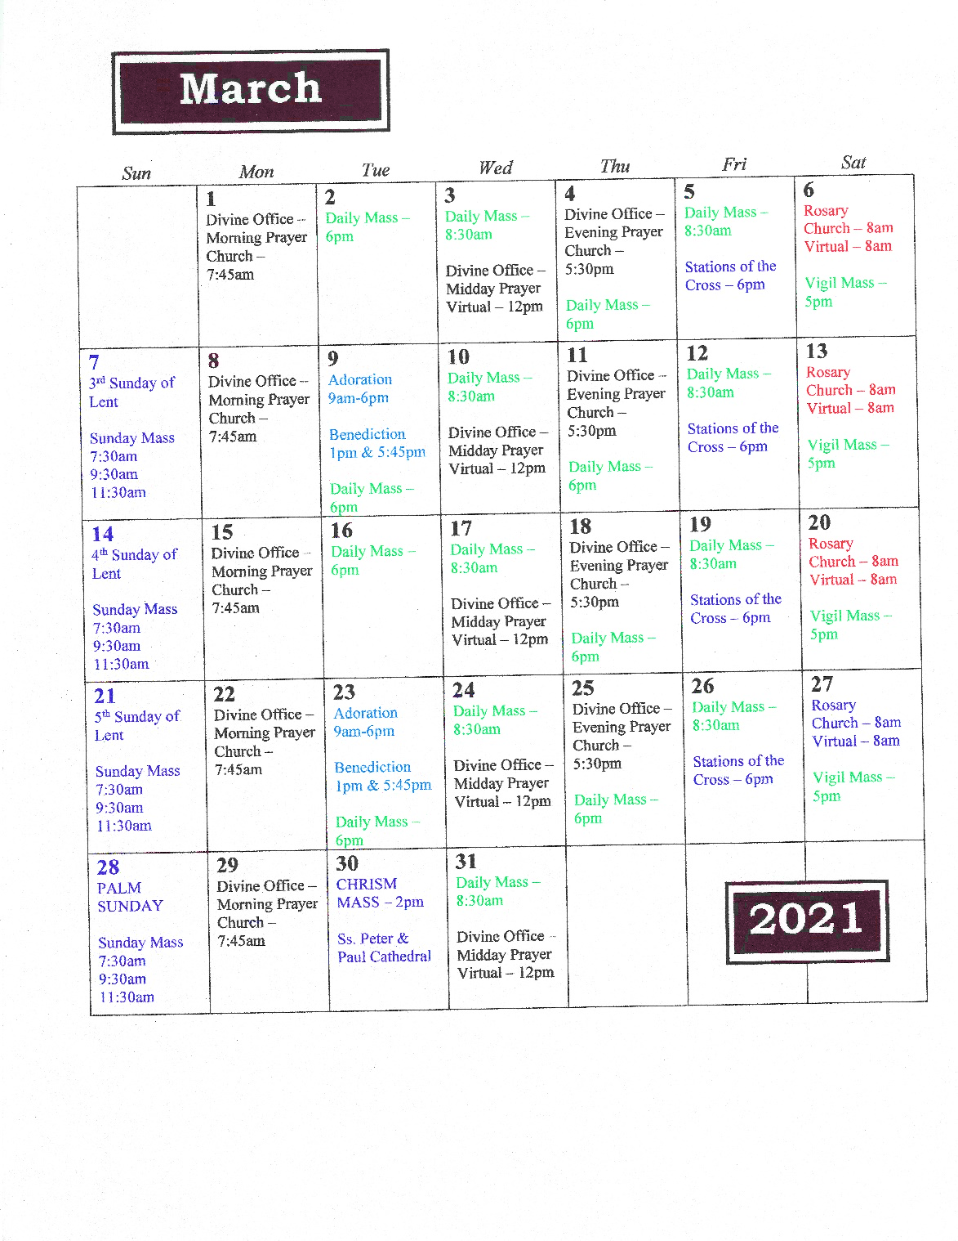

Devotion
What Spiritual aids helped you to nurture your union with Christ this month?

Study
What have you done this month to better recognize God’s gift?

Action
What apostolic success did the Lord want to accomplish in His Church through you this month?

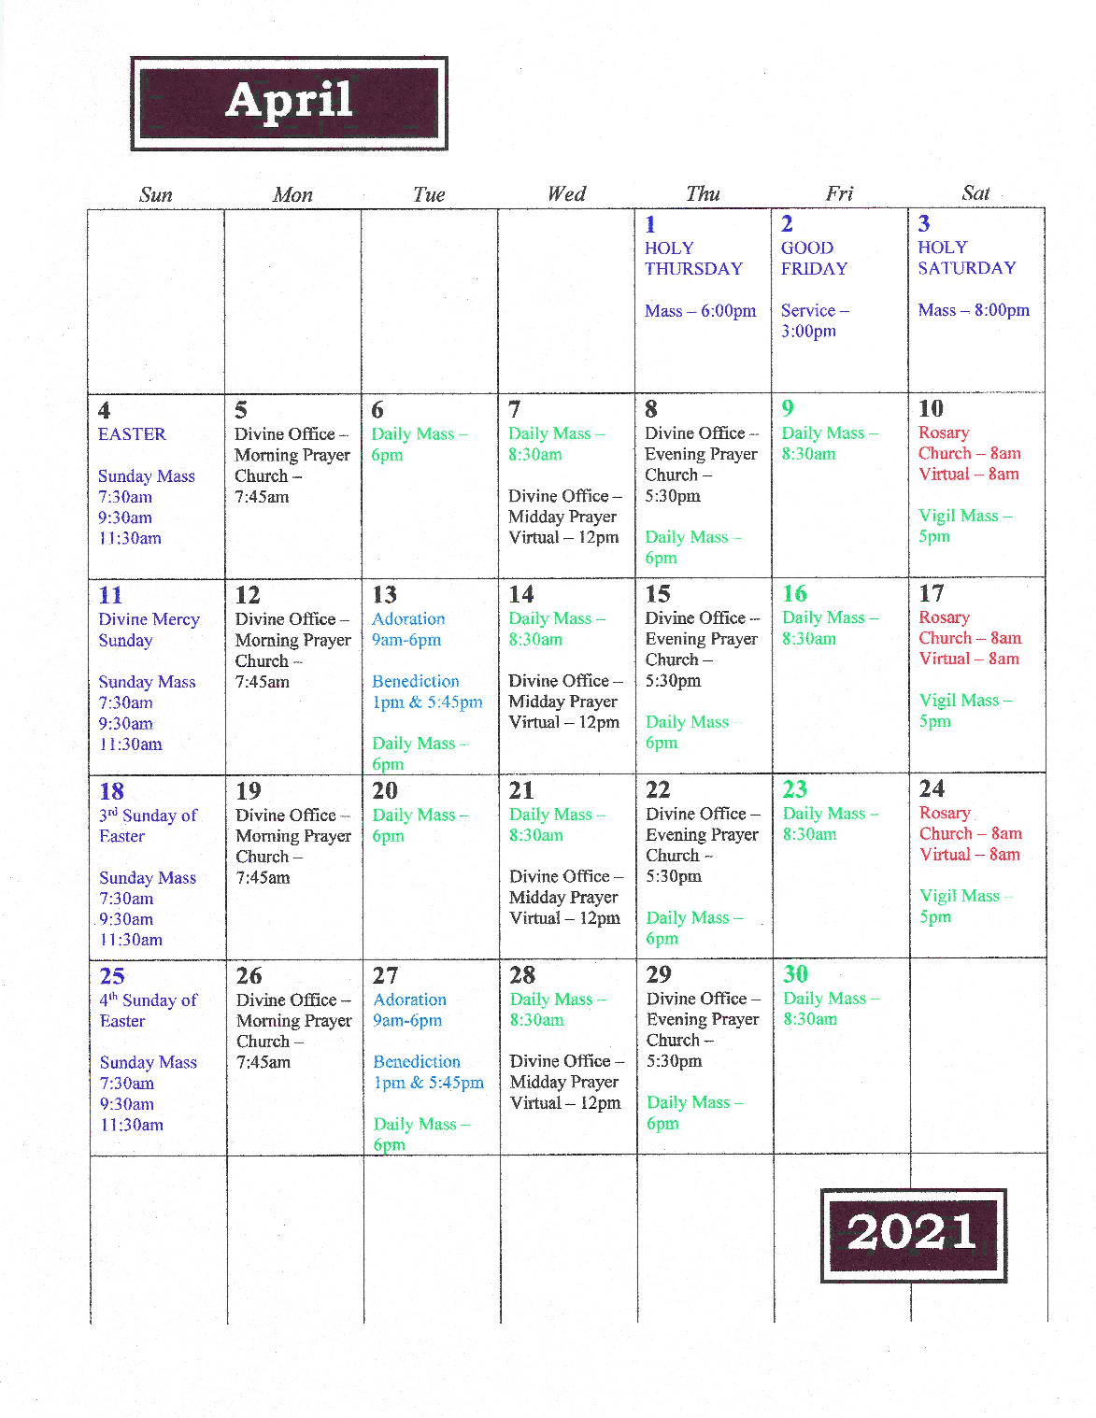

Devotion
What Spiritual aids helped you to nurture your union with Christ this month?

Study
What have you done this month to better recognize God’s gift?

Action
What apostolic success did the Lord want to accomplish in His Church through you this month?

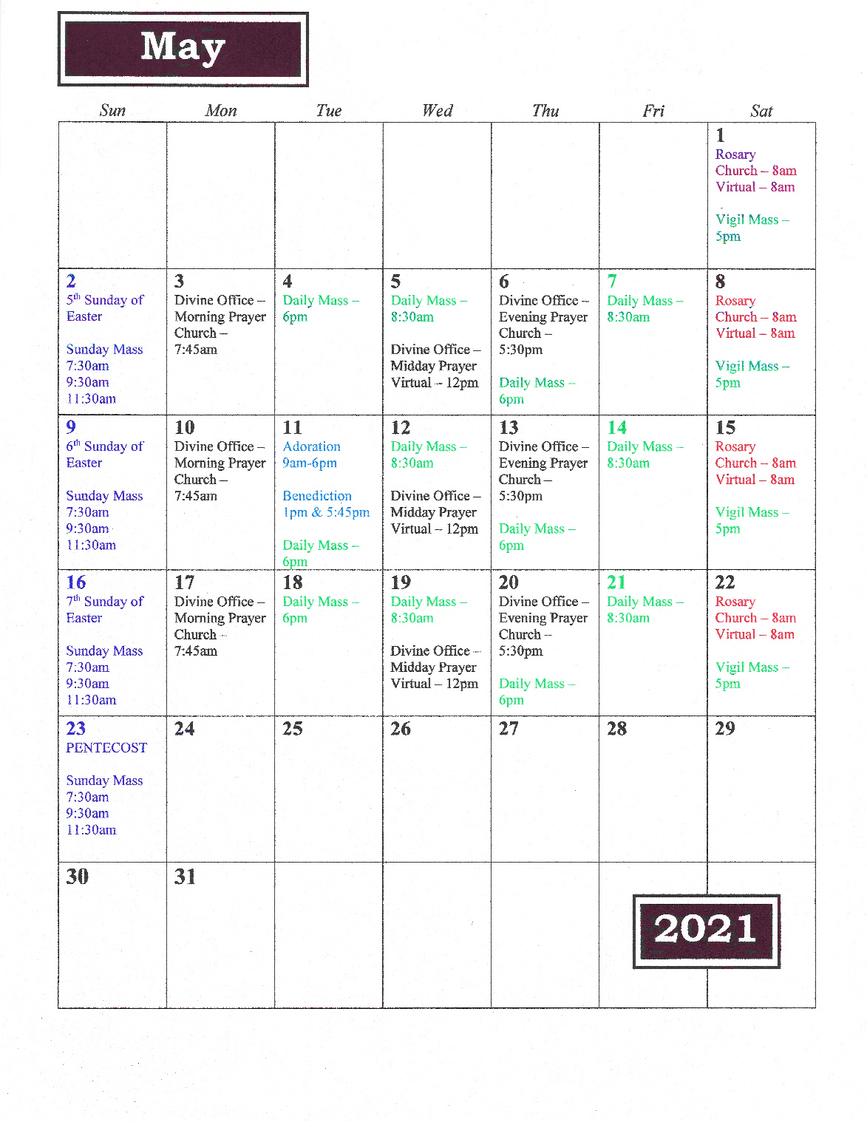

Sign up for daily Catholic
reflections or devotions

https://dynamiccatholic.com/daily-reflections
https://dailycatholicgospel.com/sign-up-daily-gospel
https://www.morningoffering.com/
https://www.loyolapress.com/3-minute-retreats-daily-online-prayer/daily-e-mail-reminders/

Books for all ages
https://paulinestore.com/
https://store.loyolapress.com/
https://www.osvcatholicbookstore.com/
https://www.ignatius.com/

Smart Phone Apps

Laudate
Hallow*
Reimagining the Examen*
iBreviary
FORMED*
Word on Fire*
Daily Readings for Catholics
Catholic Prayers, Official
EWTN*
The Word Among Us*
Fulton Sheen Audio Library
Catholic Rosary
Catholic Bible
3 Minute Retreat*
Catholic Calendar
Relevant Radio
My Catholic Life

*these apps also have a .com

Podcast

All Things Catholic
Every Knee Shall Bow
The Tightrope
Ask Fr. Josh
The Jeff Cavins Show
The Ascension Round Table
Girlfriends
The Fr. Mike Schmitz Podcast

NOTES

